

Online Registration

1. Go to https://go.pfw.edu

1. Enter username and password. All continuing, active students have a network account. Newly admitted or re-admitted students have a network account created upon admission. First time users need to click on “First-Time User” and follow the instructions to activate the network account – this includes finding out what their username is, setting up their password, and setting up a security question and answer. If the student has activated their network account but has forgotten their username or password, click on “Forgot username/password link (links identified with red arrow below). Contact ITS HelpDesk (x16030) for additional assistance. Registrar Office staff do not have access to student's network account username or password.

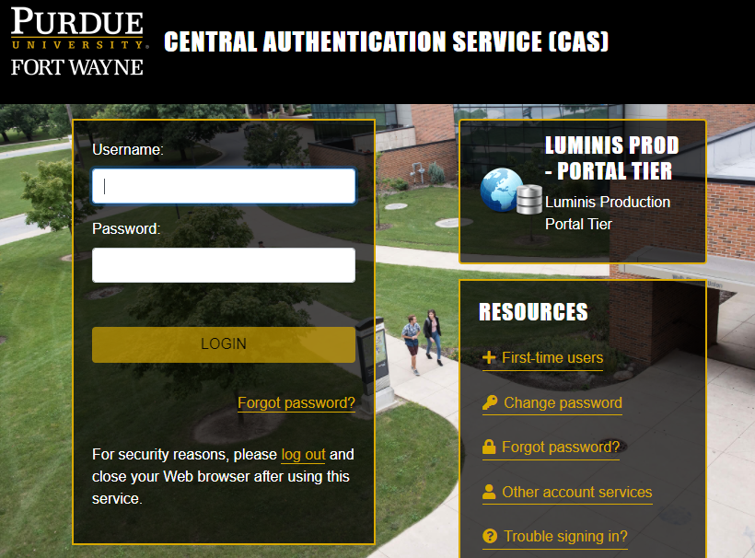

1. After logging in to goPFW, click on the enrollment tab.



1. On the Enrollment tab, there are two options for registration in the Student Services channel. If a student knows the CRNs for the courses they want to register for, click on the “Registration – Add/Drop Classes” link.

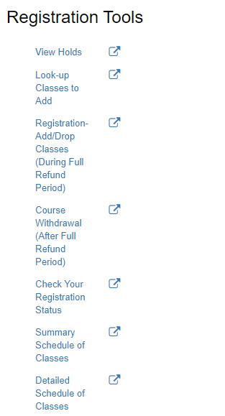

This link shows a student their class standing and when they are eligible to register. Registration priority is not set until the Friday before registration begins.

1. Select the appropriate term. Click the Submit button.

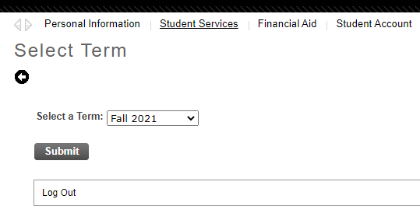

1. If the student is already registered for some classes, they will appear here. Under the “Add Classes Worksheet” heading, there are empty boxes. Enter CRNs in the boxes and click the “Submit Changes” button. If the class is added successfully, it will be added to the “Current Schedule”. If there is an error, it will appear between the “Current Schedule” and “Add Classes Worksheet” heading, with a red octagon and an explanation of the error. Notice the links to “Detailed Schedule” and “Graphic Schedule” at the bottom of the page. There are also links to pages explaining distance learning/off-campus codes, section letter codes, and registration error messages.

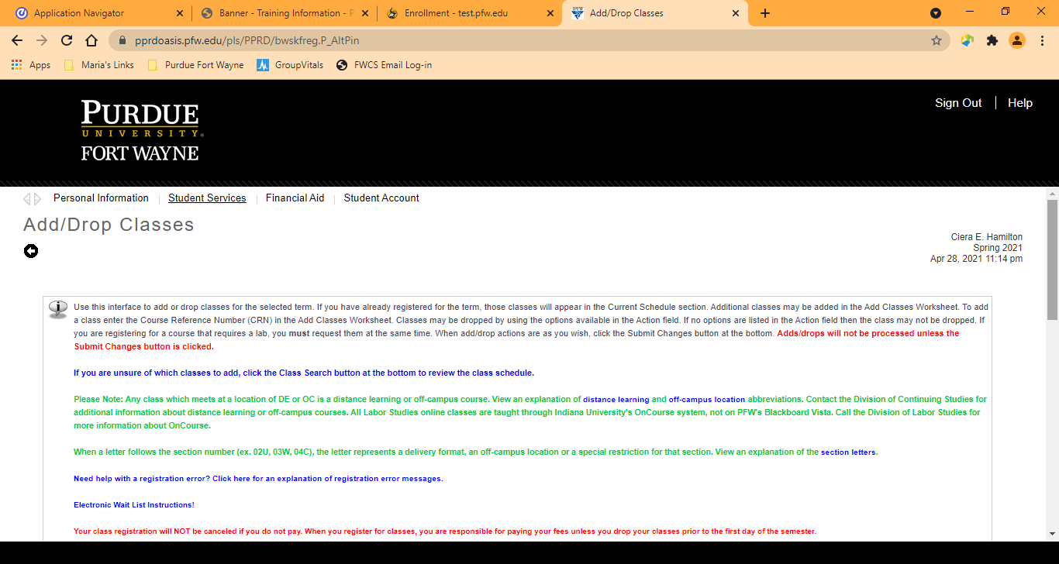

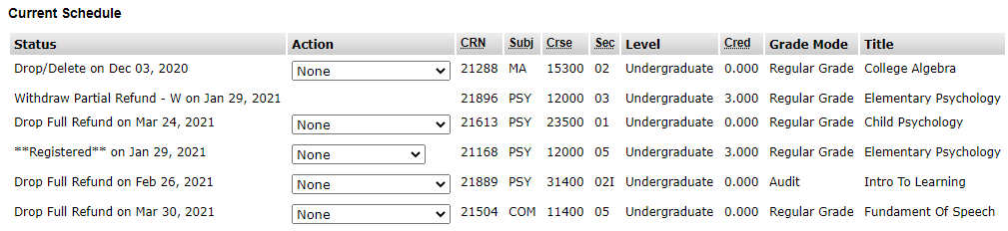

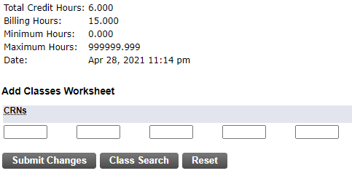

Error messages will appear here

1. The second option for registration is to click on the “Look-up Classes To Add” link from the Registration Tools channel on the Enrollment Tab. This takes the student to a searchable schedule.

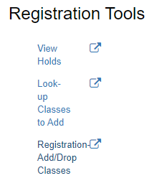

1. Select the appropriate term. Click the Submit button.

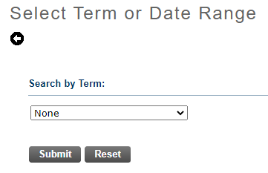

On the next screen, students have the option of doing 2 types of searches, a Course Search or an Advanced Search. Outlined first is the Course Search, after that you’ll find information about doing an Advanced Search.

COURSE SEARCH OPTION

1. The next screen allows the student to select a subject and do a course search.



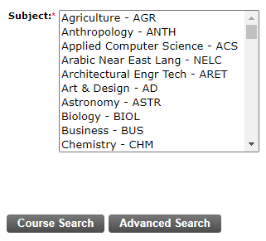

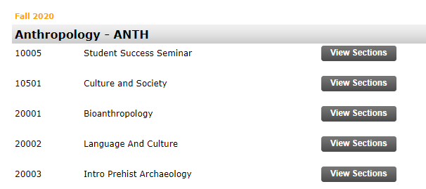

After clicking on the Course Search the student will get a list of courses offered for the specified term and subject. Click View Sections to see section offerings.

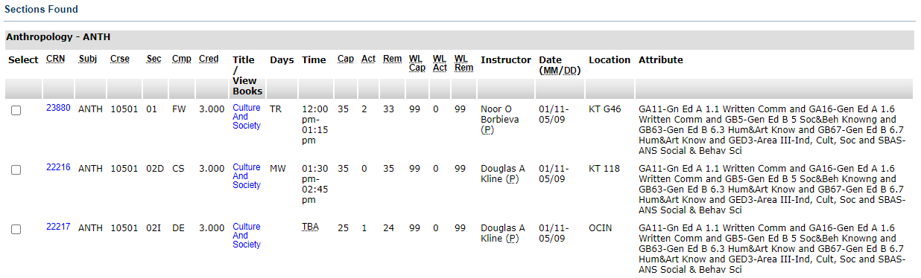



If the student finds a section they would like to register for,   
they can click the Select box and click Register.

ADVANCED SEARCH OPTION

There are many options that can be utilized in the search. The student may choose any combination of fields to narrow the search, but at least one Subject must be selected. After choosing search options, click the “Section Search” button.



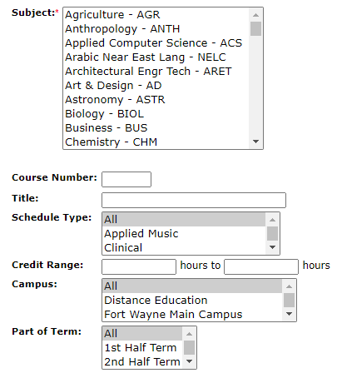

If the class is added successfully, it will be added to the “Current Schedule”. If there is an error, it will appear between the “Current Schedule” and “Add Classes” heading, with a red octagon and an explanation of the error.

