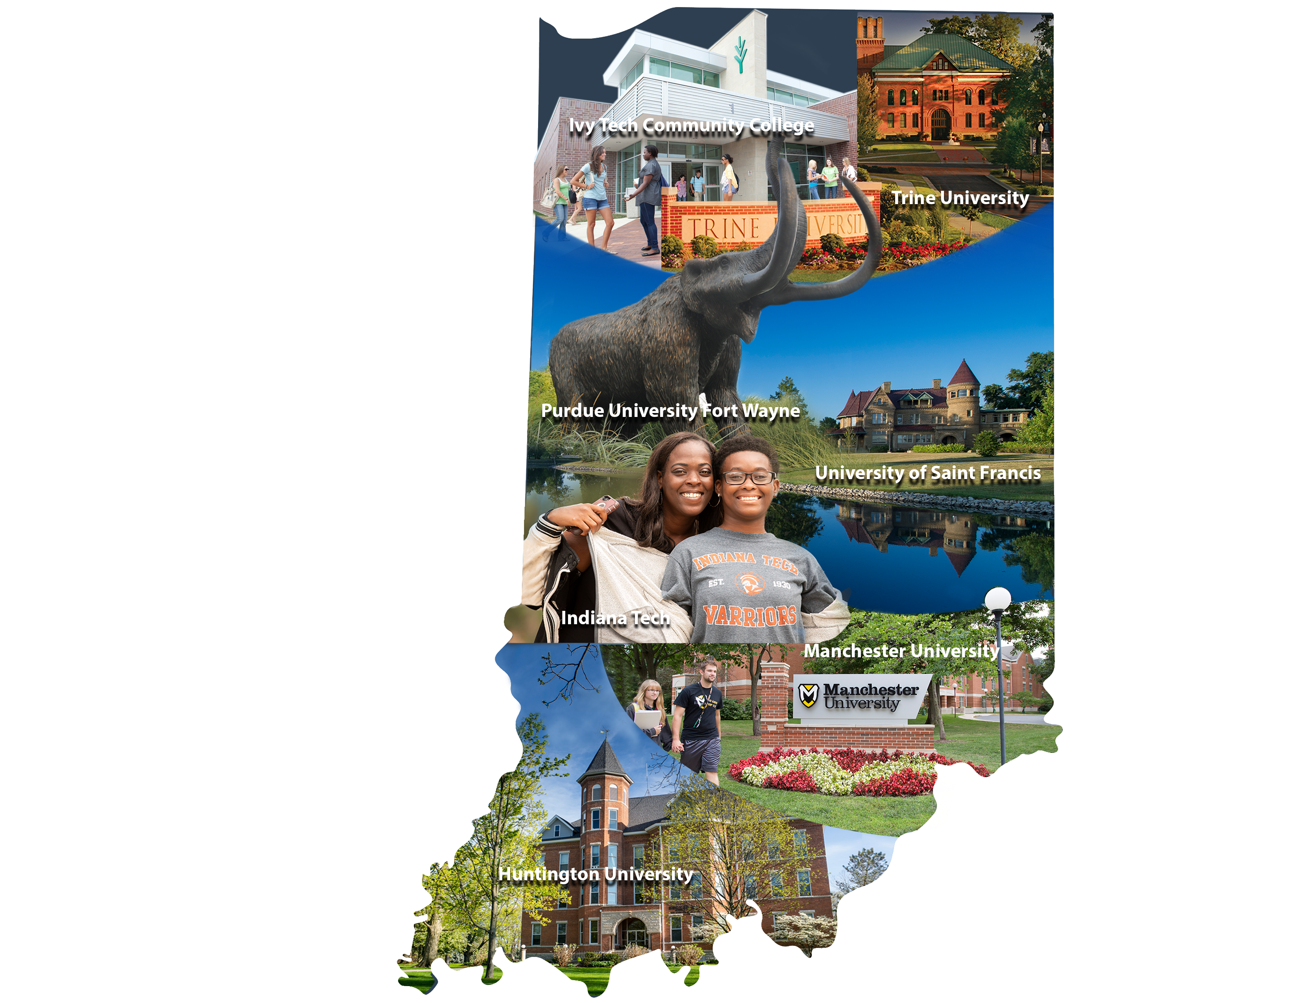

**Call for Proposals**

***2020 Fort Wayne Teaching & Learning Conference***

The 23rd annual Fort Wayne Teaching & Learning Conference will be held on

**Friday, February 21st, 2020**

**At the Purdue Fort Wayne International Ballroom**

***Bringing Educators Together to Share Great Ideas***

This conference theme offers an opportunity for faculty members and student development personnel to submit a relatively wide range of proposals. Proposal topics could include:

**Lessons learned from:**

* Applying cognitive science to learning
* Strategies to increase student engagement across modalities
* Culturally relevant teaching; i.e. first-generation, adult, millennials and international students
* Using technology to enhance learning
* Strategies to assess student performance

on Friday, December 5, 2014.This is not an exhaustive list. We encourage proposals for 25 and 45-minute sessions or round table discussions from a wide range of approaches (see session descriptions).

**Submission Deadline: Proposal submission forms (attached) must be submitted, as an email attachment, no later than 5:00 p.m. on Friday, November 15th, 2019.**

<https://www.pfw.edu/offices/oaa/faculty-support-resources/fort-wayne-teaching-conference/>

All proposals will be screened by a peer review committee. Proposals selected by the committee will be recommended to the sponsoring institutions for inclusion on the program. All individuals submitting a proposal will be informed about acceptance **by** **December 13th**. The conference program will be published on the teaching conference website in January.

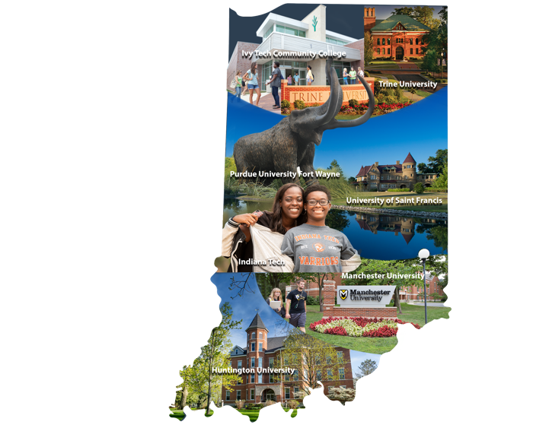

**Session Descriptions**

***2020 Fort Wayne Teaching & Learning Conference***

The 23rd annual Fort Wayne Teaching & Learning Conference will be held on

**Friday, February 21st, 2020**

**At the Purdue Fort Wayne International Ballroom**

**Lessons learned from:**

* Applying cognitive science to learning
* Strategies to increase student engagement across modalities
* Culturally relevant teaching; i.e. first-generation, adult, millennials and international students
* Using technology to enhance learning
* Strategies to assess student performance

on Friday, December 5, 2014.This is not an exhaustive list. We encourage proposals for 25 and 45-minute sessions or round table discussions from a wide range of approaches.

**25 minute sessions** should be short descriptions of teaching methods, evidence based practices and/or teaching or learning research with time for Q & A.

**45 minute sessions** should be interactive, allowing participants to experience some portion of the application of teaching methods, evidence based practices and/or teaching or learning research.

**Round table discussions** should include a very brief introduction to a central question or problem with follow-up questions prepared to generate a strong discussion. Submitters should be prepared to act as facilitators. 25 minutes.

***2020 Fort Wayne Teaching & Learning Conference***

**FWTLC Proposal Submissions**

**Please complete all answers and send as email attachment to:** [**fwtlc@pfw.edu**](mailto:fwtlc@pfw.edu) **by November 15th.**

1. Presentation Title
2. Contact information
3. Position
   * Faculty/Teacher – Full time or part time
   * Administrator
   * Staff
4. Please include a brief bio (1-2 sentences) about yourself
5. Do you have any co-presenters?
6. Please list your co-presenters with contact information
7. Brief bio of co-presenters (1-2 sentences each)
8. Type of presentation
   * 25-minute interactive session
   * 45-minute interactive session
   * Round table (25-minute discussion)
9. Presentation summary (30-50 words please)
10. Abstract (150-200 words: include sufficient information to enable reviewers to judge the quality and relevance of the proposal and attendees to make informed choices about sessions)
11. Briefly describe any evidence of success (i.e., increased student engagement, retention, better understanding, etc.)
12. Indicate your experience with this topic
13. How will you engage your audience (activity, group interaction, application, questions at the end)?
14. In what way is this information generalizable beyond your specific area/discipline?
15. Will you need any audio/visual equipment? Other equipment?- please indicate any specific requirements. If yes, will you be using a powerpoint presentation?