**PURDUE UNIVERSITY FORT WAYNE**

**Department of Communication**

**Assistant Professor of Rhetoric**

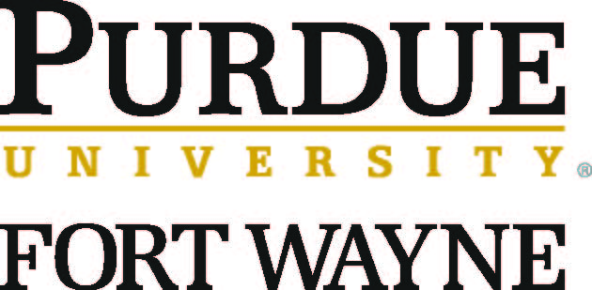

The Department of Communication at Purdue University Fort Wayne IPFW) seeks an Assistant Professor to teach undergraduate and graduate courses in rhetorical theory and criticism with specialization in media studies, political communication, health communication and public advocacy beginning August 2019. The successful candidate will demonstrate a commitment to and expertise in teaching and research and will hold a doctorate in Communication by the start of employment.

The Department and University are committed to providing inclusive educational experiences for our urban and regional constituents.  The Department has thriving undergraduate and masters programs and a collegial and professionally active faculty.  Current faculty members teach and do research in the following areas: interpersonal, organizational, intercultural, race and gender, communication education, cultural studies, rhetoric, media and legal communication.

The Department affirms diversity.  Additional information about the Department and University is available at <http://www.pfw.edu/comm>

Purdue University Fort Wayne is a Master’s Comprehensive I institution with 10,000 students from the city of Fort Wayne and the surrounding region. Fort Wayne is the second largest city in Indiana with about 250,000 residents. Fort Wayne offers affordable housing, multiple school systems, a diverse arts community, and excellent health care systems.

Applicants should submit a letter of application, vita, evidence of teaching effectiveness, 1-2 page teaching philosophy, samples of scholarship, and names and contact information for four current references to:

Dr. Michelle Kearl, Interim Chair

Search and Screen Committee

Department of Communication

Purdue University Fort Wayne

2101 E Coliseum Blvd

Fort Wayne, IN 46805-1499.

Screening will begin October 31 and continue until the position is filled. All candidates who are interviewed should prepare a 45-60 minute instructional presentation. We will meet with qualified applicants at NCA.

Purdue University Fort Wayne is an EEO/AA employer fully committed to achieving a diverse workforce. All individuals, including minorities, women, individuals with disabilities, and protected veterans are encouraged to apply.