Managing Your Employee Profile in SuccessFactors Quick Reference Guide
Last Updated: 2/26/2019

This Quick Reference Guide outlines the primary tasks employees might complete within their Employee Profile in SuccessFactors. Additional resources and documentation can be found on the SuccessFactors Training Page, found at https://www.purdue.edu/hr/successfactors/training/index.php.

Contents
Accessing SuccessFactors 1
Viewing Your Pay Statement 1
Recording Time - Positive Duration or Negative Duration 2
Recording Time - Webclock 3
Requesting Time Off 4
Editing Personal Information 6
Editing Bank Information 6
Editing Tax Information 7

Accessing SuccessFactors
Use an internet browser to visit the OneCampus Portal (https://one.purdue.edu/).  Click Employee Launchpad |  |  |  | 
Log in using Purdue Career Account ID and BoilerKey passcode.  For assistance using or setting up BoilerKey, please contact ITaP at itap@purdue.edu or 765-494-4000. |  |  |  | 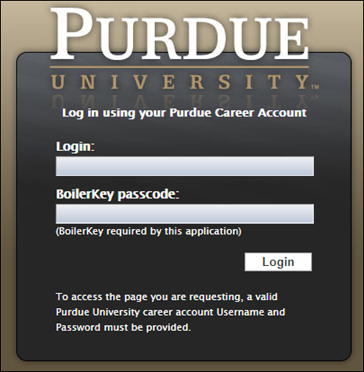

Viewing Your Pay Statement
Scroll down to the My Info section  Click the Pay Statements 1/1/2019 to Present tile | 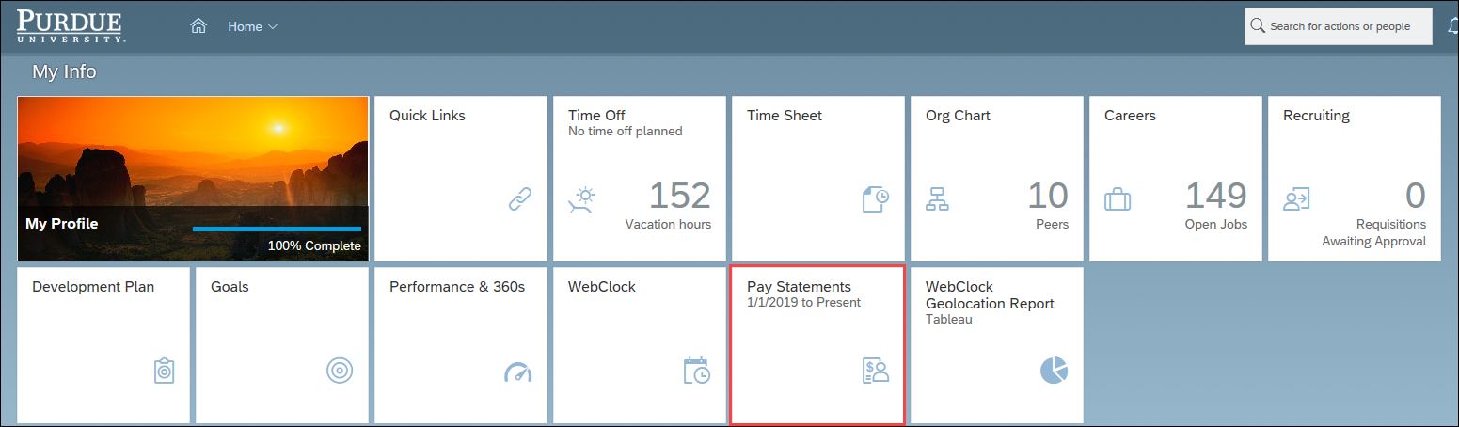

Recording Time - Positive Duration or Negative Duration
This section applies to individuals who utilize Positive Duration Entry or Negative Duration Entry timekeeping. For detailed resources and instructions for time entry, please visit www.purdue.edu/timehelp.
If you hold multiple positions, use the Change Selected Employment menu to select the position for which you would like to record time |  |  | 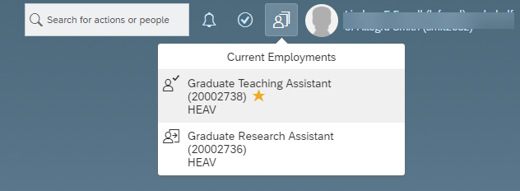
If you hold multiple positions and they are similarly named, click My Profile to validate that the correct position has been selected |  |  | 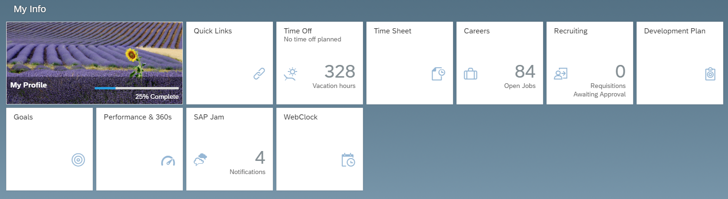
If you hold multiple positions and they are similarly named, click the Employment Information tab to view the details of the position selected in order to ensure time is recorded for the correct position. |  |  | 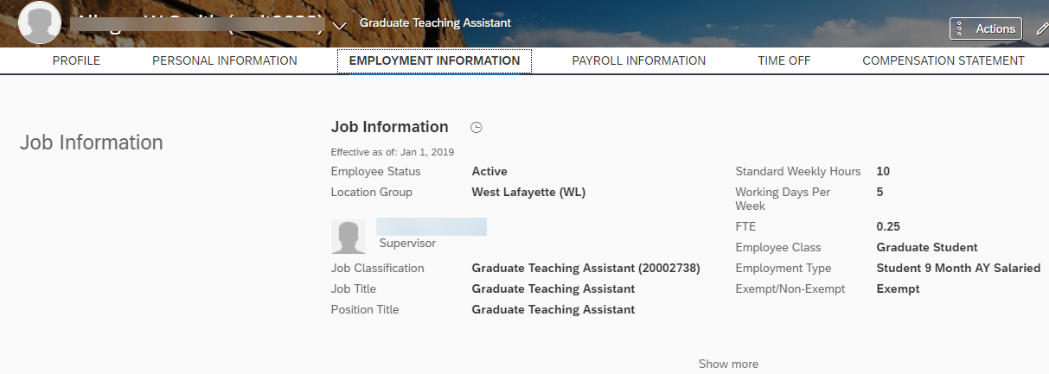
(If you completed the previous steps to verify multiple positions, return to the SuccessFactors home page and select the desired position).

Scroll down to the My Info section

Click the Time Sheet tile

Recording Time - Webclock
This section applies to individuals who utilize Webclock timekeeping. For detailed resources and instructions for time entry, please visit www.purdue.edu/timehelp.
Scroll down to the My Info section

Click the Webclock tile

Requesting Time Off
The example below is a basic personal Time Off request. Detailed resources and documentation related to Time Off requests, including cheat sheets and video demonstrations, can be found on the SuccessFactors Training Page, found at https://www.purdue.edu/hr/successfactors/training/index.php.
If you hold multiple positions, use the Change Selected Employment menu to select the position for which you would like to record time
If you hold multiple positions and they are similarly named, click My Profile to validate that the correct position has been selected
If you hold multiple positions and they are similarly named, click the Employment Information tab to view the details of the position selected in order to ensure time off is requested for the correct position.
(If you completed the previous steps to verify multiple positions, return to the SuccessFactors home page and select the desired position).

Click the Time Off tile
- Click the type of leave being requested, or select it from the Time Type field  - Select from the calendar or enter the date(s) being requested in the Start Date and End Date fields  - In the Requesting field, select or enter the amount of time being requested  - Optional: Enter a comment for your supervisor  - Click Submit or Cancel. | 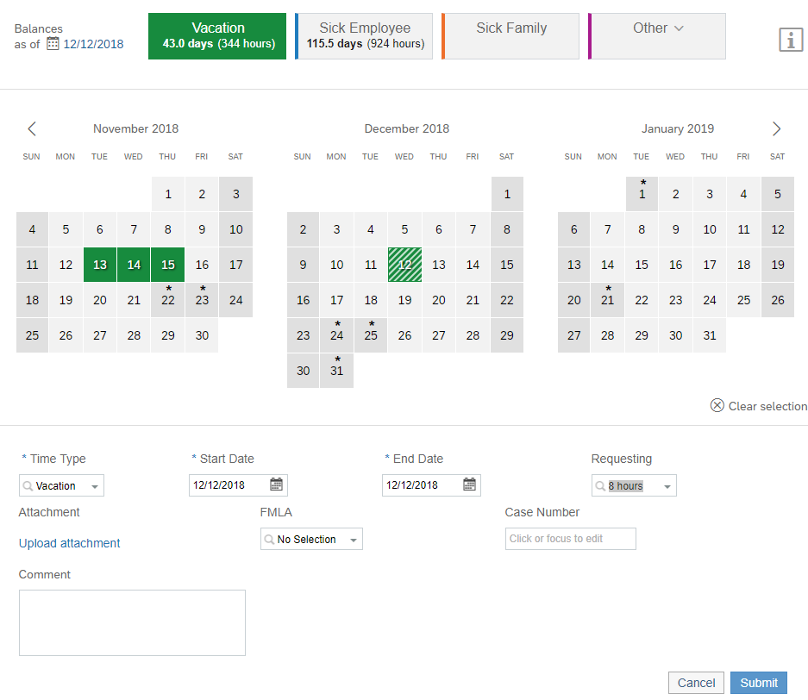  5  4  3  2  2  1

Editing Personal Information
Scroll down to the My Info section

Click the My Profile tile

Click the PERSONAL INFORMATION tab | 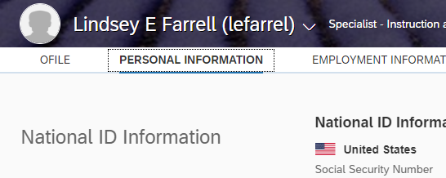
Only the following information is editable. Contact your business office / center to edit other information.  - Home Address  - Home Phone Number  - Emergency Contact  Click Edit (the pencil icon ) to edit the fields. | 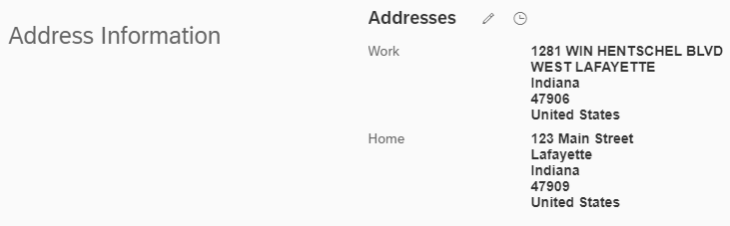

Editing Bank Information
Scroll down to the My Info section

Click the My Profile tile

- Click the PAYROLL INFORMATION tab  - Click Bank ESS | 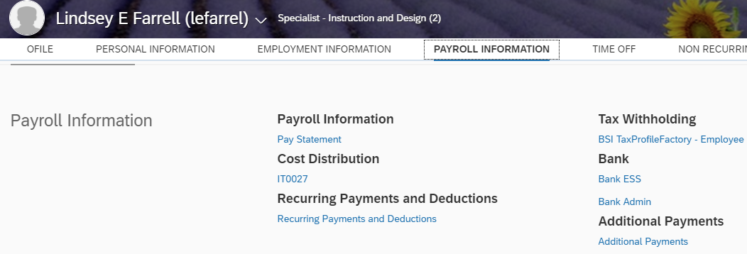  2  1
Click Edit (the Pencil icon) to edit bank info.  Click Other bank to add new bank. | 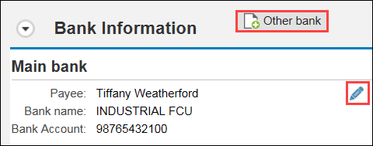

Editing Tax Information
Scroll down to the My Info section

Click the My Profile tile

- Click the PAYROLL INFORMATION tab  - Click BSI TaxProfileFactory – Employee  Make any necessary adjustments and submit. |  | 2  1

